1. Explore SL

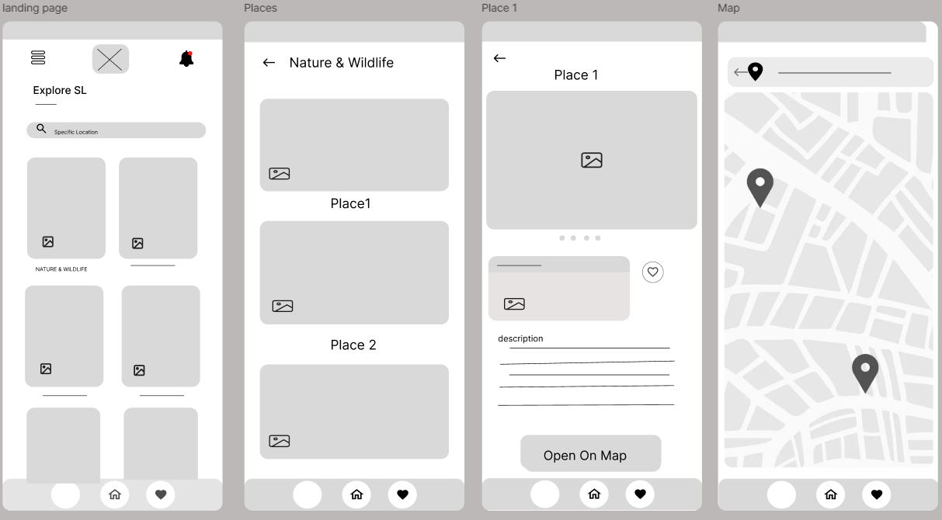

* Browse places categorized into Nature & Wildlife, Coastal & Beaches, Cultural & Historical, and Hill Country & Scenic Spots.
* Detailed descriptions, images, and current weather updates for each location.
* Favourite places feature for easy access.

Interactive map integration for navigation